  - Resistors in Series
Key Revision Facts: GCSE Science

Combining two or more resistors will increase the resistance of the circuit.
Total Resistance = R1 + R2 + R3 + R4
Total Resistance = 1k + 2k + 3k + 4k
Total Resistance = 10k

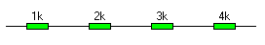

Example

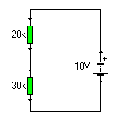
The current of the circuit can be calculated by adding the values of the resistors and using OHM’s law.

Total resistance =20k+30k=50k

I = V = 10 = 0.2A
R 50

